**For Completed Bookings Details**

Add Remarks as one of the categories

Rep: Have changed it. Please check

**For Calendar Page**

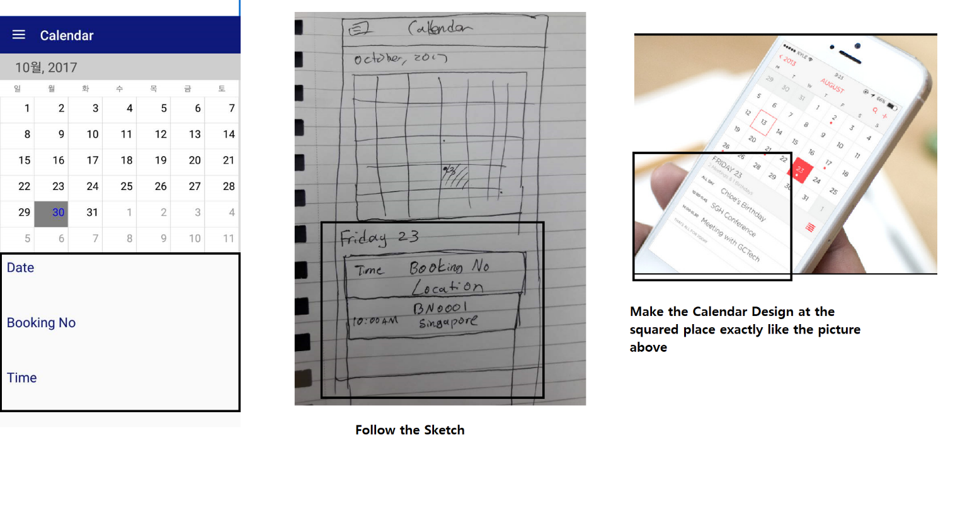

Rep: Have changed it. Please check

**For Profile Page**

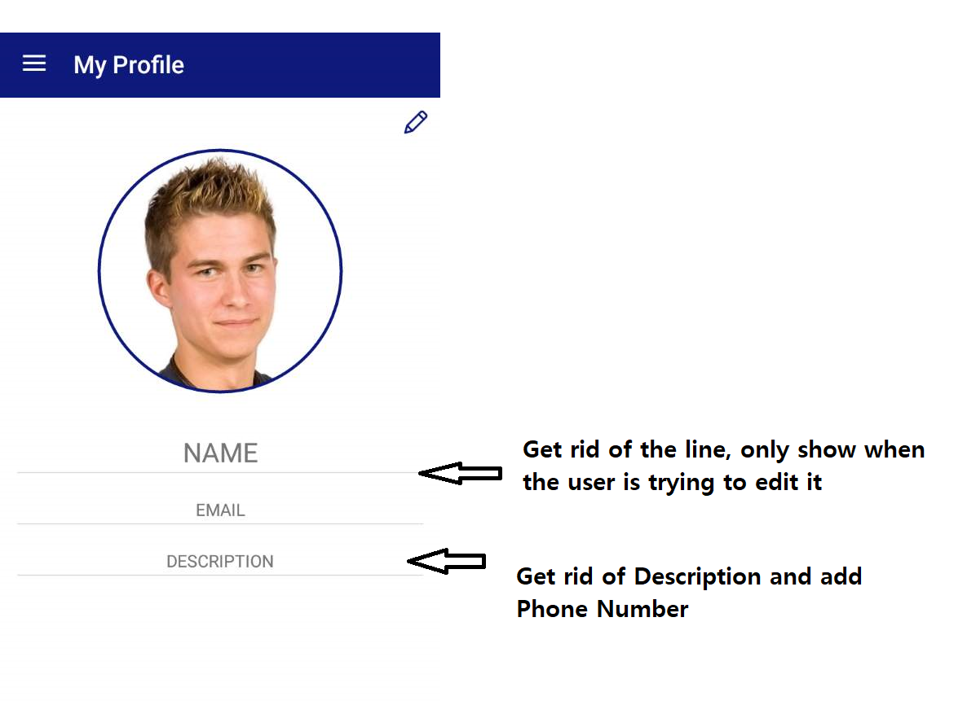

Rep: Have changed it. Please check

**Note: Also cannot show when user click an edit button.**